Final Year Project Technical Report
BSc Computing



NLP-Driven Financial Document Pre-Review and Anomaly Detection

Oisin Gibson
L00172671

Declaration

- I have accurately identified and included the sources of all facts, ideas, opinions, and viewpoints from others in the assignment references. All direct quotations, paraphrasing, and discussions of ideas from books, journal articles, internet sources, course materials, or any other sources used are properly acknowledged and cited in the assignment references.
- I have not used unauthorised artificial intelligence tools or aids.
- I understand and am compliant with ATU's policy and procedures regarding Academic Integrity and I am aware of the consequences of any violations.
- I have followed the referencing guidelines recommended in the assignment instructions and / or programme documentation.
- I understand that not adhering to the word limits on each section will result in penalties.
- By signing this form or by submitting material online I confirm that this assignment, or any part of it, has not been previously submitted by me or any other person for assessment on this or any other programme of study.
- By signing this form or by submitting material for assessment online I confirm that I have read and understood AQAE022 Academic Integrity Policy.

I confirm I agree to this declaration. ☒

Print Signature: Oisin Gibson

Date: 12/12/2025

Acknowledgements
I would like to thank my supervisor Dr Kevin Meehan for his support and guidance over the course of the project in his role as project supervisor. In addition, I would like to offer my thanks to Robbie Quinn, CEO Helix Partnership LTD, for stepping into the role of gatekeeper for the project.

Table of Contents
1. Project Overview 1
1.1. Purpose 1
1.2. Objectives 1
1.2.1. Specific objectives 1
1.3. Project Scope 2
1.3.1 In Scope 2
1.3.2 Out of Scope 3
2. Requirements 4
2.1. Functional Requirements 4
2.2. Non-Functional Requirements 7
2.3. Data Processing Summary 11
3 System Architecture & Design 12
3.1 Hardware and Software Requirements 12
3.2 High-Level System Architecture 12
3.2.1 Presentation Layer 13
3.2.2 Application Layer 13
3.2.3 Analytical Layer 14
3.3 Key Components, Functions, and Interactions 15
3.4 Description of System Features and Workflows 16
3.5 Design and Implementation Constraints 21
3.6 System Qualities 21
3.6.1 Maintainability 21
3.6.2 Extensibility 21
3.6.3 Scalability 22
3.7 Security Protocols and Considerations 22
3.8 Testing Strategy 22
4 Data Requirements 25
4.1 Data Sources and Characteristics 25
4.2 Data Model and Schema 25
4.3 Data Storage Requirements 27
4.4 Data Flow 28
4.5 Data Volume and Performance Constraints 29
4.6 Data Privacy, Ethics, and Security Requirements 29
4.7 Data Quality Requirements 30
5 Implementation 31
5.1 Implementation Approach and Development Methodology 31
5.2 Development Environment and Tools 31
5.3 Planned Codebase Structure 32
5.4 Step-by-step Implementation Plan 32
5.4.1 Sprint 1 32
5.4.2 Sprint 2 33
5.4.3 Sprint 3 33
5.4.4 Sprint 4 33
5.4.5 Sprint 5 33
5.5 Deployment and Runtime Strategy 34
5.5.1 Local Deployment 34
5.5.2 Cloud Deployment (Resource depending) 34
5.6 Privacy, Security, and Data Governance 35
5.7 Error Handling and System Observability 35
5.8 Testing Strategy 35
6 Testing & Evaluation 36
6.1 Testing Objectives 36
6.2 Testing Methodology 36
6.3 Unit Testing Plan 37
6.4 Integration Testing Plan 37
6.4.1 Frontend -> Backend 37
6.4.2 Backend -> NLP pipeline 37
6.4.3 Backend <-> Storage 38
6.5 System / End-to-End Workflow Testing 38
6.6 NLP Evaluation Metrics 38
6.6.1 NER Evaluation 38
6.6.2 Topic Modelling Evaluation 38
6.6.3 Summarisation Evaluation 39
6.6.4 Anomaly Detection Evaluation 39
6.7 Security & Penetration Testing 39
6.8 Success Criteria 39
7 Conclusion 40
8 References i
9 Appendix A: Report Structure Example iv
10 Appendix B: Code Listing / GitHub Project Link vi

Table of Figures
Figure 1 Use Case Diagram 10
Figure 2 Component Diagram 11
Figure 3 High Level Diagram 15
Figure 4 Activity Diagram 20
Figure 5 Class Diagram 23
Figure 6 Sequence Diagram 24
Figure 7 Entity Relationship Diagram 27
Figure 8 Data Flow Diagram 29
Figure 9 Sprint Timeline 34

Glossary of Terms
Term | Definition
Artificial Intelligence (AI) | The development of computer systems that can perform tasks that typically require human intelligence, such as learning, problem-solving, and decision-making.
Portable Document Format (PDF) | A file format for capturing and sending electronic documents in exactly the intended format
Natural Language Processing (NLP) | A field of artificial intelligence and computer science that enables computers to understand, interpret, and generate human language.
Tokenisation | A fundamental step in Natural Language Processing (NLP) that breaks down text into smaller units called "tokens," such as words, sub words, or characters
Stopword removal | A text pre-processing technique that involves deleting common but uninformative words like "the," "is," and "a" from a body of text
Lemmatization | A natural language processing (NLP) technique that reduces a word to its base or dictionary form, called a lemma.
Term Frequency-Inverse Document Frequency (TF-IDF) | A statistical measure in Natural Language Processing (NLP) used to evaluate how important a word is to a document within a collection (corpus)
Latent Dirichlet Allocation (LDA) | An unsupervised machine learning technique used for topic modelling, which automatically discovers the hidden thematic structure in a collection of documents
BERTopic | An advanced, unsupervised topic modelling technique that leverages modern transformer models (like BERT) and a class-based variation of the TF-IDF algorithm (c-TF-IDF) to create dense, easily interpretable, and high-quality topics
Name Entity Recognition (NER) | A key technique in Natural Language Processing (NLP) that automatically identifies and classifies important information, known as "named entities," within unstructured text into predefined categories.
TextRank | A general-purpose graph-based ranking algorithm in NLP.
ROUGE-1 | Measures the overlap of unigrams (single words) between a machine-generated summary and a human-written reference summary.
Bilingual Evaluation Understudy (BLEU) | A metric which is used to evaluate the quality of machine-generated text by comparing it to one or more reference texts.
Optical Character Recognition (OCR) | A technology which converts images of text into machine readable and editable text. Used to scan documents or handwritten text which allows the user to search, edit or copy the previously static content.
General Data Protection Regulation (GDPR) | European Union law that protects an individual’s personal data and harmonizes data privacy laws across EU countries.
Hypertext Transfer Protocol Secure (HTTPS) | The secure version of HTTP which encrypts the data transmitted between the user’s browser and a website.

Project Overview

Purpose
Financial document analysis is a crucial function when it comes to maintaining accuracy and trust within the financial and auditing sectors. However, much of this data still comes in unstructured formats such as Portable Document Format (PDFs), Word documents and spreadsheets. This results in workplace professionals having to manually review the files to identify anomalies. This process is not only time-consuming but prone to human error and inefficient at a large scale.
The aim of this project is to design and implement a web-based Natural Language Processing (NLP) system which will automate the extraction and analysis of financial documents at the earliest stages of reviews. The system will use techniques such as NLP, Named Entity Recognition (NER) and extractive summarisation to process the uploaded files and generate concise summaries while also highlighting potential anomalies.
The system aims to assist the workplace professionals with correctly identifying key insights and anomalies. This should in theory reduce the workload while also improving consistency, accuracy and efficiency in financial document analysis.

Objectives
The main aim of this project is to build a system that will demonstrate how NLP can be used to automate this early-stage review of financial documents. The core functionally will see the system extract, summarise and analyse financial documents while also flagging potential anomalies for further investigation.

Specific objectives
- Text Extraction: Have the system be able to extract readable text from PDF, DOCX and XLSX files.
- Pre-processing: Implement tokenisation, stopword removal, and lemmatisation with a processing time averaging under two seconds per document.
- Topic Modelling: Identify the core financial topics using TF-IDF and LDA. Evaluate BERTopic as an alternative.
- Entity Recognition: Detect key financial entities and relationships within the documents using NER.
- Summarisation: Implement TextRank in order to extract summaries from the documents. Access the performance using ROUGE and BLEU metrics.
- Anomaly Detraction: Flag anomalies detected by developing a rule-based module. Anomalies will be assigned traffic-light rating (Green, Amber, Red).
- System Integration: Develop a prototype with a frontend using React and Node.js/Express for the backend. JWT will be used for user authentication.
- User Usability: Conduct a user experience test with the aims of achieving 80% satisfaction rating in regard to usability and relevance.

Project Scope
The project will focus on the development of a functional prototype of a web-based application that implements NLP functionality. The aim of this prototype is to automate the early-stage review of financial data. Various key modules will be implemented to perform text extraction, summarisation, and anomaly detection. The theory is that this process will enable efficient and scalable analysis of financial documents.
The system will also implement authentication and robust handling of the financial data which ensures privacy and compliance.
To evaluate the effectiveness and performance of the NLP components, established metrics will be employed. Summarisation quality will be measured using Bilingual Evaluation Understudy (BLEU) and Recall-Oriented Understudy for Gisting Evaluation (ROUGE) scores while the anomaly detection features will be measured using precision, recall and accuracy. BLEU is a widely used metric that is used to assesses the overlap of n-grams between generated and reference texts. The metric was originally introduced by Papineni. (Papineni et al., 2002a). The ROUGE metric, developed by Lin, complements BLEU by focusing on recall-based comparisons. (Lin, 2004) .This is particularly effective for the summarisation tasks in this system.

1.3.1 In Scope
- Development of a functional prototype.
- Implement NLP-based modules for the text extraction, summarisation, and anomaly flagging features.
- Secure user authentication and handling of the financial data.
- Evaluate the NLP performance using pre-established NLP metrics.

1.3.2 Out of Scope
- Advanced deep learning models.
- Full-scale financial auditing or reporting generation.
- Real-time deployment in a production environment.
- Analysis of sensitive, non-anonymous financial data.
The system will be developed using anonymised datasets, provided by Helix Innovation Partnerships Ltd. The datasets will be processed within a secure environment within Microsoft Azure to ensure privacy and ethical compliance.

Requirements
This section of the report outlines the functional and non-functional requirements of the system. The different requirements for the project were derived from the literature on Section 1 and from the technical constraints covered during the planning stage. The functional requirements specify what the system must do, while non-functional requirements specify the quality attributes and operational standards the system must achieve. Paired together they provide the foundation for the design, implementation, and evaluation of the system.

Functional Requirements
FR1 - User Authentication
Secure authentication mechanism will be implemented within the system using bcrypt for password hashing and JSON Web Tokens (JWT) for session control. This process ensure that only authorised users are able to upload and analyse financial documents. By using industry-standard authentication, the project aligns with GDPR compliance and best practices for web security. (mrbullwinkle, 2025a).
FR2 - Document Upload and Management
System users will be able to upload financial documents in multiple formats, including PDF, DOCX, and XLSX. Once uploaded, these files will be processed through a secure API endpoint and temporarily stored within a Microsoft Azure environment. This functionality ensures the system can seamlessly accommodate the diverse data formats commonly encountered in financial analysis workflows, enhancing both flexibility and efficiency. (Hegghammer, 2022a).
Code Listing 1 PDF Upload Function
print("Please upload your financial document (PDF):")
print("Please upload your financial document (PDF):")
uploaded = files.upload()

if not uploaded:
raise SystemExit("No file uploaded. Please run the cell again and upload a PDF.")

pdf_path = list(uploaded.keys())[0]
print("Using file:", pdf_path)

uploaded = files.upload()

if not uploaded:
raise SystemExit("No file uploaded. Please run the cell again and upload a PDF.")

pdf_path = list(uploaded.keys())[0]
print("Using file:", pdf_path)

FR3 – Text Extraction
The system will be able to extract machine-readable text from the uploaded financial documents. This will be accomplished using a combination of parsing and Optical Character Recognition (OCR) techniques. For proof-of-concept testing, Google Colab will be used to validate the functionality and performance of the workflow. Depending on usability in terms of the reach of this project, Azure Form Recognizer or Apache Tika will be employed for text extraction. This will ensure that tabular and multi-column content is accurately captured. This is an essential process for handling unstructured financial documents, often which contain embedded table or footnotes. (Hegghammer, 2022a).

Code Listing 2 Text Extraction Function
print("\nExtracting narrative sentences from OCR text...")

full_text = "\n".join(page_texts)
sentences = sent_tokenize(full_text)

narrative_rows = []

for s in sentences:
s_clean = s.replace("\x0c", " ").strip() # remove strange page-break characters
if not s_clean:
continue

section = classify_section(s_clean)
nums = extract_financial_numbers(s_clean)

current_val = nums[0][1] if len(nums) > 0 else ""
prior_val = nums[1][1] if len(nums) > 1 else ""

narrative_rows.append({
"section": section,

"value_current": current_val,
"value_prior": prior_val,
"names": ", ".join(extract_names(s_clean)),
"dates": ", ".join(extract_dates(s_clean))
})

df_narrative = pd.DataFrame(narrative_rows)
print(f"Narrative sentences extracted: {len(df_narrative)} rows.")

print("\nExtracting narrative sentences from OCR text...")

full_text = "\n".join(page_texts)
sentences = sent_tokenize(full_text)

narrative_rows = []

for s in sentences:
s_clean = s.replace("\x0c", " ").strip() # remove strange page-break characters
if not s_clean:
continue

section = classify_section(s_clean)
nums = extract_financial_numbers(s_clean)

current_val = nums[0][1] if len(nums) > 0 else ""
prior_val = nums[1][1] if len(nums) > 1 else ""

narrative_rows.append({
"section": section,
"text": s_clean,

"text": s_clean,
"value_current": current_val,
"value_prior": prior_val,
"names": ", ".join(extract_names(s_clean)),
"dates": ", ".join(extract_dates(s_clean))
})

df_narrative = pd.DataFrame(narrative_rows)
print(f"Narrative sentences extracted: {len(df_narrative)} rows.")

"value_current": current_val,
"value_prior": prior_val,
"names": ", ".join(extract_names(s_clean)),
"dates": ", ".join(extract_dates(s_clean))
})

df_narrative = pd.DataFrame(narrative_rows)
print(f"Narrative sentences extracted: {len(df_narrative)} rows.")

FR4 – Text Pre-Processing
After the text has been extracted the system will then prepare the data for downstream NLP tasks. This will be accomplished by applying methods such as tokenisation, stopword removal, and lemmatisation. The pipeline used for pre-processing shall be optimised to achieve an average processing time of under two seconds per document. To prevent the removal of any key financial terms, domain-aware token retention will be implemented. (InstituteAdmin, 2025a). The token retention will be looking out for terms such as balance or equity. (Lu and Huo, 2025).
FR5 - Topic Modelling
Using Term Frequency-Inverse Document Frequency (TF-IDF) and Latent Dirichlet Allocation (LDA), the system will be able to identify dominant financial themes within the documents. If resources allow, BERTopic will be used as an alternative for a more semantically coherent clustering. (Zvornicanin, 2022a). The process of topic modelling will provide insight into recurring subjects and anomalies that may require further evaluation.
FR6 – Named Entity Recognition (NER)
NER is the process which will be implemented to identify key financial entities. Such entities may be the company name, monetary amounts, dates or reporting periods. The module will use fine-tuned corpora to ensure high precision and recall. (Shah et al., 2024a). The entity recognition aspect will convert the unstructured text into structured data. This data can then be cross-referenced and validated by the system.
FR7 - Summarisation
The TextRank algorithm will be employed to provide extractive summaries of the uploaded financial documents. Rather than use abstractive methods to preserve factual and numerical accuracy, summarisation was instead chosen. This is essential for regulatory contexts. (Chae et al., 2024). BLEU and ROUGE metrics will later be used to evaluate the quality of the summarisation. (Papineni et al., 2002b; Lin, 2004).
FR8 – Anomaly Detection
Using a rule-based anomaly detection module, potential irregularities in the data will be flagged for review. Each of the documents will be categorised using a pre-established traffic-light system.
- Green being normal
- Amber being review
- Red being critical
Using this approach will enable interpretable and transparent anomaly scoring. (PricewaterhouseCoopers, 2023a).
FR9 – User Interface and Feedback Logging
Using React, a dashboard will display the various document summaries, key topics and the anomaly scores. The system will allow the users to review the flagged sections and provide feedback on said sections. The collected feedback will the be used to measure the usability of the system and further be used guide improvements. (Peerdh, 2023).

Non-Functional Requirements
NFR1 – Performance
The system aims to maintain efficient performance by processing small documents within three seconds. The various NLP components will be optimised for minimal latency so as to support interactive review sessions. (Wang et al., 2024a).
NFR2 – Scalability
The aim is to have the prototype support ten suers without degradation in system performance. This ensures that the system architecture remains viable for any small-to-medium enterprise.
NFR3 – Security
The communication between the client and the server will occur over HTTPS. The user data will be safeguarded using JWT-based sessions and bcrypt for password hashing. The financial data will stay secure on the system and will not be transferred to any third-party APIs. (mrbullwinkle, 2025b).
NFR4 – Usability
The evaluation survey shall target an overall satisfaction score of at least 80%. Achieving this threshold will demonstrate the system’s intuitive design, as well as the effectiveness of its navigation structure and visual cues in guiding users through flagged anomalies. (Isreal and Alonge, 2025)
NFR5 – Reliability and Availability
The system aims to maintain an uptime of at least 95% during the evaluation periods. By implementing error-handling and retry features, continuity can be ensured in the event of a transit failure or interruptions during upload.
NFR6 – Maintainability
By using GitHub for version control, the project will be able to follow a modular design pattern. The building of the project will also be documented, aiding with issue tracking which in turn will also support reproducibility and the long-term maintenance.
NFR7 – Portability
The system itself will be primarily hosted on Microsoft Azure. However, it does also need to be deployable locally using open-source alternatives. Other methods of accomplishing this will be investigated, if time permits, such as scikit-learn or spaCy. This functionality will ensure the continued functionality under various network environments.
NFR8 – Compliance and Ethics
All datasets used for this project are supplied and anonymised by Helix Partnership LTD. This ensures that the project will follow the guidelines set out by ATU’s ethics committee. The system itself is designed to act as a decision-support tool rather than a replacement for professional based judgement. (Badmus, Toromade and Adebayo, 2025).
NFR9 – Accessibility
The system will comply with WCAG 2.1 AA accessibility standards where development allows. These accessibility standards would include keyboard navigation, sufficient colour contrast, and ARIA labels for screen-reader compatibility. Such features will ensure that the system is inclusive in its usability for users who may have disabilities. It also ensures that the project keeps in line with modern accessibility standards in software development. (Initiative (WAI) and Henry, 2005).
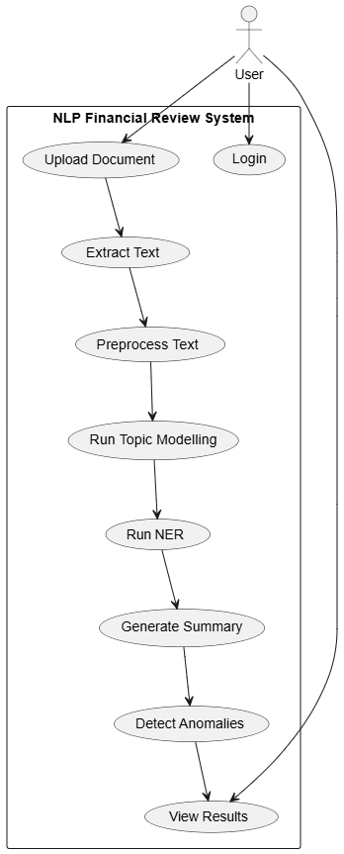
Figure 1 Use Case Diagram
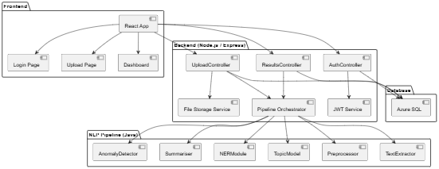
Figure 2 Component Diagram

Data Processing Summary
The system life cycle begins when a user uploads a financial document through the web interface. The text extraction module will then retrieve machine-readable content from the document, followed by tokenisation and cleaning. After this functionality is completed, the text passes through the topic-modelling, entity recognition and summarisation stages. Following this the anomaly detection aspect will assign a traffic light classification to the document before the final output, that being summary, entities and anomaly score, is displayed. The final display will be shown through the React dashboard for the user’s interpretation. This sequential flow ensures that the system had consistency, auditability, and the potential for quantitative evaluation in later testing.

System Architecture & Design
The system architecture for this project will be developed to support the secure handling of financial data, modular linguistic processing and efficient interaction between various system components. The project supports a structured, layered architecture model which comprises of a React-based frontend, Node.js/Express backend, and a Java powered NLP pipeline. As stated in the Project Proposal, this approach to development emphasizes usability, modularity, privacy, and explainability as key design principles. As identified in the literature reviewed, this approach to system creation shows how NLP systems benefit from pipeline-based workflows. This is further shown where workflows separate ingestion, pre-processing, modelling, and anomaly detection in order to minimize error occurrence and maximise interpretability. (Wang et al., 2024a).

Hardware and Software Requirements
The system will be developed using standard hardware which features at least 16 GB of RAM, a multi-core CPU, and SSD storage which will ensure stable performance when running. Although research shows that financial data is more computationally expensive, the chosen algorithms were selected to counter these limitations as they do not require GPU acceleration. The decision to build the system using this developmental approach aligns with the constraints discussed in the Project Proposal. Said constraints included the need for a system deployable on typical enterprise grade hardware without the need for costly infrastructure.
The software environment will consist of a React.js frontend, a Node.js/Express backend, and a Java NLP processing module which uses libraries such as Apache Tika, Apache OpenNLP, and Stanford CoreNLP. The tools selected were chosen for their maturity, stability, and widespread industry adoption. For the text extraction process, the system will optionally interface with Azure Form Recognizer. From the literature reviewed, this form of text extraction has shown to be effective in its handling of multiple column documents with complex layout patterns. (Hegghammer, 2022b). GitHub will be used for version control of the project. This enables a structured collaboration and supports the Agile methodology mentioned in the project proposal. The run time communication will be secured using HTTPS while user authentication is covered by bcrypt and JWT. This approach ensures that the project complies with standard GDPR and Azure data-handling guidelines. (JudithPRA, 2025).

High-Level System Architecture
The high-level architecture design for the system follows a three-layer structure:
- A presentation layer
- An application layer
- An analytical layer
This layered design best aligns with established principles in distributed systems engineering. It ensures modularity, scalability, and maintainability at each stage of the project life cycle. By isolating various functional requirements across the different system layers, the architecture supports the independent scaling of different components. It also enforces secure data flow between each of the three layers and provides a clear separation of concerns. In summary, such a structure will reduce complexity, facilitate testing, and also allow future development to be integrated with minimal disruption.

Presentation Layer
The presentation layer of the system will be implemented using React. This was chosen for its compartment-based architecture, strong ecosystem, and its ability to deliver responsive, dynamic interfaces. It is this layer which will provide the user with the functionality to submit the financial documents, review them, and interact with the system as a whole.
One of the core non-functional requirements was accessibility. With this in mind, the interface will be designed to comply with WCAG 2.1 AA standards, which ensures usability for users with diverse needs. These standards best align with industry practices and guidelines from the Web Accessibility Initiative (WAI). (Initiative (WAI) and Henry, 2005). Beyond this, Reacts’s virtual DOM and its efficiency in rendering mechanisms contribute to performance, which ensures the system remains responsive even under high user load.

Application Layer
The application layer for the system will be implemented using Node.js/Express. These were chosen as they provide a lightweight, event—driven backend framework which is best suited to handling concurrent requests. This layer will be responsible for:
Authentication and Authorization: Implementation will be done using JWT-based stateless sessions. This will reduce the reliance on server-side storage and minimize attack vectors.
Routing and API Management: Functionality will include coordinating the requests between the presentation and analytical layers of the system.
File Handling: This section will handle the secure upload of the financial documents. Validation and preparation of the documents for analysis will also be covered under this functionality.
Security Enforcement: In order to best safe-guard data, controls such as input sanitization, rate limiting, and encryption will be implemented into the system.
The stateless design of the systems backend should enhance the scalability of the system. This will allow for horizontal scaling across multiple instances without there being overhead in relation to session management. This approach will also improve resilience as the individual nodes can be scaled or even replaced without major impact on the user sessions.

Analytical Layer
The NLP pipeline will be hosted on the analytical layer of the system. It is here that the systems core language-processing tasks are performed. Such functions include tokenization, entity recognition, anomaly detection, and summarization which is tailor made to handle financial documents.
The key design features include:
Local Processing: The financial documents are processed locally rather than having them transmitted to an external API. By doing this the risk for data leaks is mitigated. Research shows that privacy is a critical concern in financial NLP deployment. (Badmus, Toromade and Adebayo, 2025).
Ethical Compliance: All the sensitive financial data will remain under the control of the system, aligning with the ethical constraints set out.
Cloud Compatibility: The system will aim to integrate with Microsoft Azure which will enable elastic compute scaling, advanced AI services, and hybrid deployment models. This will ensure portability and extensibility for the system, which allows it to adapt to various workloads.
Hybrid Deployment Strategy: The system design aims to support both on-premises and cloud=based extraction. This would balance the security aspects with scalability.
The analytical layer aims to achieve a balance between security, scalability, and extensibility by combining privacy-preserving local processing with cloud integration. This implementation aims to address the system various non-functional requirements.

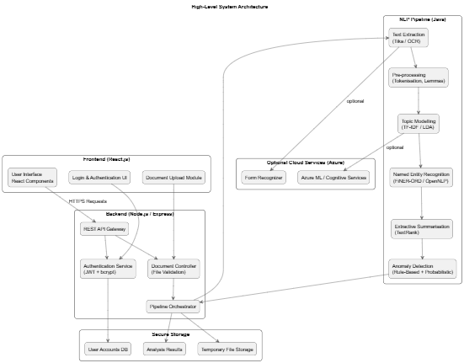
Figure 3 High Level Diagram

Key Components, Functions, and Interactions
Interactions between the various system components will follow a well-defined workflow which will ensure security, modularity, and data integrity. HTTPS will be implemented where the frontend interacts with the backend, never accessing the processing modules directly. The aim of implementing this approach is to reduce the viable attack surface and it also aligns with the advice from the literature reviewed. Such research puts a heavy emphasis on strict separation between the user interface and the processing components. (Shah et al., 2024a).
The systems backend component is what is responsible for handling all incoming requests, validating user credentials, receiving uploaded files, and initiating the document analysis process. Once the uploaded document is accepted by the system, the backend will then create a Document instance. This instance will then be forwarded for extraction and processing. The NLP pipeline itself will consist of several coordinated modules:
- Text extraction
- Pre-processing
- Topic Modelling
- NER
- Summarisation
- Anomaly detection
Each of the modules will produce structured output which will then be passed to subsequent modules. This reflects the pipelines architecture which is often recommended in a natural language system design. (InstituteAdmin, 2025b).
The NLPProcessor, which sequences the operations, will be what controls the interactions between the various modules. The anomaly detection system will be what evaluates the consistency between the extracted entities, summary content, financial terms, and the expected structure of the document. These processes will use a combination of rule-based logic and probabilistic checks. The aim of this hybrid design is to address the liitations of machine-learning anomaly detectors which have been identified in the reviewed literature. (Ji, Dong and Driggs-Campbell, 2022; PricewaterhouseCoopers, 2023b).

Description of System Features and Workflows
Within the system there will be several inter-connected features, each driven by certain domain requirements and adhering to the best practices in financial NLP. The workflow will begin with the uploading of the documents on the frontend, these documents can be in a variety of formats including PDF, DOCX, or XLSX. Once uploaded, the backend will validate the file type, size, and user permissions before the file can be forwarded or extracted. According to the literature reviewed, the extraction accuracy is the most influential factor concerning NLP performance. The system will also incorporate a robust parsing module with a fallback OCR. (Jin et al., 2025).
Methods such as tokenisation, noise removal, stop-word filtering, and lemmatisation will be applied within the pre-processing workflow. These will incorporate a stop-word filtering list which will identify and prevent the elimination of financial terms such as “liability” or “balance”. This is essential as, according to the reviewed literature, it will significantly reduce topic coherence and the accuracy of NER. (Zvornicanin, 2022b).
In order for the system to have the ability to identify recurring issues, topic modelling will be implemented. This process will highlight the high-value themes within the management accounts and the financial statements. Models trained on corpora such as FiNER-ORD will be utilized for the named entity recognition aspect of the system. (Shah et al., 2024a). This will see the extraction of structured financial entities from the uploaded documents. With these features implemented, other tasks within the system will be supported, such as anomaly detection and summarisation.
TextRank will be implemented into the extractive summarisation module to ensure that the generate summaries remain factual and numerically stable. The aim for this section would be to address hallucination issues which were reported in abstractive financial models. (Chae et al., 2024). The document will be evaluated by the anomaly-detection module using a combination of rule-based checks and probabilistic scoring which will be informed by linguistic anomalies.
print("\n======================")
print(" SUMMARY")
print("======================\n")

def fmt(value):
"""Format a numeric value as €x,xxx or return 'N/A'."""
if value in ("", None):
return "N/A"
try:
return f"€{float(value):,.0f}"
except:
return str(value)

# 1. Key metrics
print("🔹 KEY FINANCIAL METRICS:")
for metric, value in metrics.items():
print(f" • {metric:30s}: {fmt(value)}")

print(f" • {'Employees':30s}: {employees if employees else 'N/A'}")

# 2. YOY changes
print("\n🔹 YEAR-ON-YEAR CHANGES (if two years detected):")
if yoy_summary:
for metric, pct in yoy_summary.items():

print(f" • {metric:30s}: {pct}% ({direction})")
else:
print(" Only one year detected or insufficient data for YOY.")

# 3. Directors' report highlights
print("\n🔹 DIRECTORS’ REPORT HIGHLIGHTS:")
directors_highlights = df_narrative[df_narrative["section"] == "directors_report"]["text"].tolist()
if not directors_highlights:
print(" No directors' report text detected.")
else:
for point in directors_highlights[:5]:
snippet = point[:250] + ("..." if len(point) > 250 else "")
print(f" • {snippet}")

# 4. Notes to the accounts
print("\n🔹 NOTES TO THE ACCOUNTS (Key Policies):")
notes_highlights = df_narrative[df_narrative["section"] == "notes"]["text"].tolist()
if not notes_highlights:
print(" No notes text detected.")
else:
for point in notes_highlights[:5]:
snippet = point[:250] + ("..." if len(point) > 250 else "")
print(f" • {snippet}")

# 5. Assets & liabilities overview
print("\n🔹 ASSET & LIABILITY OVERVIEW:")
print(f" • Tangible Assets: {fmt(metrics.get('Tangible assets'))}")
print(f" • Stocks: {fmt(metrics.get('Stocks'))}")
print(f" • Debtors: {fmt(metrics.get('Debtors'))}")
print(f" • Cash: {fmt(metrics.get('Cash'))}")
print(f" • Creditors <1 Year: {fmt(metrics.get('Creditors <1 year'))}")
print(f" • Creditors >1 Year: {fmt(metrics.get('Creditors >1 year'))}")
print(f" • Net Current Assets: {fmt(metrics.get('Net current assets'))}")
print(f" • Net Assets: {fmt(metrics.get('Net assets'))}")

# 6. Summary sentence on performance
print("\n🔹 PERFORMANCE SUMMARY:")
turn = metrics.get("Turnover")
prof = metrics.get("Profit for the year")
if turn and prof:
print(f" The company recorded turnover of {fmt(turn)} and a profit of {fmt(prof)} "
f"in the latest financial year.")
else:
print(" Turnover and/or profit figures could not be reliably detected.")

print("\n======================")
print(" END OF SUMMARY REPORT")
print("======================\n")

print(f" • {metric:30s}: {pct}% ({direction})")
else:
print(" Only one year detected or insufficient data for YOY.")

# 3. Directors' report highlights
print("\n🔹 DIRECTORS’ REPORT HIGHLIGHTS:")
directors_highlights = df_narrative[df_narrative["section"] == "directors_report"]["text"].tolist()
if not directors_highlights:
print(" No directors' report text detected.")
else:
for point in directors_highlights[:5]:
snippet = point[:250] + ("..." if len(point) > 250 else "")
print(f" • {snippet}")

# 4. Notes to the accounts
print("\n🔹 NOTES TO THE ACCOUNTS (Key Policies):")
notes_highlights = df_narrative[df_narrative["section"] == "notes"]["text"].tolist()
if not notes_highlights:
print(" No notes text detected.")
else:
for point in notes_highlights[:5]:
snippet = point[:250] + ("..." if len(point) > 250 else "")
print(f" • {snippet}")

# 5. Assets & liabilities overview
print("\n🔹 ASSET & LIABILITY OVERVIEW:")
print(f" • Tangible Assets: {fmt(metrics.get('Tangible assets'))}")
print(f" • Stocks: {fmt(metrics.get('Stocks'))}")
print(f" • Debtors: {fmt(metrics.get('Debtors'))}")
print(f" • Cash: {fmt(metrics.get('Cash'))}")
print(f" • Creditors <1 Year: {fmt(metrics.get('Creditors <1 year'))}")
print(f" • Creditors >1 Year: {fmt(metrics.get('Creditors >1 year'))}")

print(f" • Net Current Assets: {fmt(metrics.get('Net current assets'))}")
print(f" • Net Assets: {fmt(metrics.get('Net assets'))}")

# 6. Summary sentence on performance
print("\n🔹 PERFORMANCE SUMMARY:")
turn = metrics.get("Turnover")
prof = metrics.get("Profit for the year")
if turn and prof:
print(f" The company recorded turnover of {fmt(turn)} and a profit of {fmt(prof)} "
f"in the latest financial year.")
else:
print(" Turnover and/or profit figures could not be reliably detected.")

print("\n======================")
print(" END OF SUMMARY REPORT")
print("======================\n")

print(f" • Net Current Assets: {fmt(metrics.get('Net current assets'))}")
print(f" • Net Assets: {fmt(metrics.get('Net assets'))}")

# 6. Summary sentence on performance
print("\n🔹 PERFORMANCE SUMMARY:")
turn = metrics.get("Turnover")
prof = metrics.get("Profit for the year")
if turn and prof:
print(f" The company recorded turnover of {fmt(turn)} and a profit of {fmt(prof)} "
f"in the latest financial year.")
else:
print(" Turnover and/or profit figures could not be reliably detected.")

print("\n======================")
print(" END OF SUMMARY REPORT")
print("======================\n")

Ghgfg

Code Listing 3 Summarisation Function

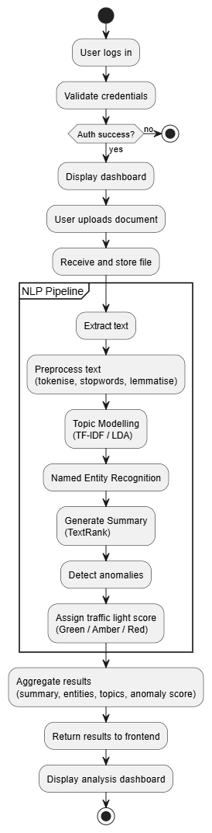
Figure 4 Activity Diagram

Design and Implementation Constraints
There were several factors that influenced the design constraints of the project such as privacy, explainability, computation, and time. With the nature of the financial datasets being sensitive information, external API-based processing could not be used. (Du et al., 2025). Adhering to this constraint aligns with concerns expressed in the Azure OpenAI governance research. (mrbullwinkle, 2025b). Here it was emphasized the implementation of strict data isolation and privacy controls within a system. Based on this, the system will rely on local processing meaning all the NLP libraries will need to be lightweight, open-sourced, and compatible with offline execution.
Explainability, which takes the form of summarization in the system, was another constraint that needed to be addressed. The system users needed to be able to understand why the system produced the summary it did. Literature reviewed showed the risk of black-box ML systems, which reduced transparency when auditing. (Wang et al., 2024b). With this in mind, this project will aim to implement interpretable models that will make the processes more user friendly.
As with any project, there will be limitations as to what resources can be used during development. The aim here will be to use all available resources and implement them to their fullest potential so as to get the best results for each segment of the project. With that in mind, time restraints also are a major constraint. Having roughly twelve weeks means sticking to a rigid schedule but even with this there may have to be some sacrifices made. Such sacrifices may be reworking different sections depending on the ease of its implementation.

System Qualities

Maintainability
One of the key architecture goals of this project was ensuring it maintainability. This will be achieved through the separation of the system into a React frontend, Node backend, and Java NLP processor to allow each section to be updated independent of the other. The overall aim of this separation will be to facilitate the replacement or updating of certain segments of the system. If construction of the system goes as planned, the pipeline should support any enhancements with minimal refactoring of modules.

Extensibility
The modular class design of the class of the system is what will be supporting the extensibility of the project. While the plan is to have the NLPProcessor class coordinate execution, individual modules can be upgraded or substituted if the need arises. An example would be if SHAP-explainable ML classifiers were included in the anomaly detection aspect of the system. (Lundberg and Lee, 2017).

Scalability
Scalability within the project will be accomplished via the stateless backend and cloud-compatible pipeline. If time and resources will permit, the system will be deployed in a multi-instance environment such as Azure App Service. This will allow multiple users to submit documents concurrently without impacting the overall performance of the system as a whole. Through structured error handling, strict input validation, and fallback mechanisms, reliability can be achieved within the system.

Security Protocols and Considerations
Due to the nature of the documents being uploaded to the system, security is an essential design requirement. All system users will have their credentials hashed using bycrypt before being stored. This will prevent plaintext expose in the even of a database breach. In order to ensure secure, stateless session management, JWT tokens will be implemented. As well as this, all data transmission that takes place between the systems front and back end will be done using HTTPS. To added to this encryption, the backend component of the system will enforce strict access control though role-based authorisation.
The documents will only be temporarily stored and then automatically deleted after the analysis is completed, unless configured otherwise. Due to GDPR-compliance requirements and literature reviewed, no external services will receive the files due to the risks associated. (Badmus, Toromade and Adebayo, 2025). All inputs will also be sanitised, and file types will be restricted to known formats so as to mitigate injection and deserialization risks.

Testing Strategy
Testing is a critical step in any system project. For the purpose of this system a variety of different methods will be utilized. Such methods will include unit, integration, system, usability, and performance testing. The aim of the unit tests will be to validate individual components within the system, such as pre-processor, NER engine, and anomaly detection logic. The integration testing aspect will ensure that the outputs from one module can then be used reliably by another. (InstituteAdmin, 2025b). System testing will evaluate the end-to-end workflow from the user login to anomaly presentation.
As the name suggests, performance testing will access the over performance of the system. This will range from document processing speed to certain other non-functional requirements. The aim is to have a professional from Helix Innovation Partnerships Lid conduct a usability test of system once completed. This has yet to be confirmed however research shows that having real-world expert evaluation is essential for validating any system. (Larusdottir, Bjarnadottir and Gulliksen, 2010).

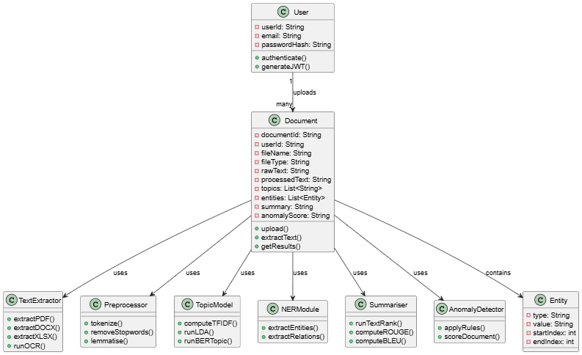
Figure 5 Class Diagram

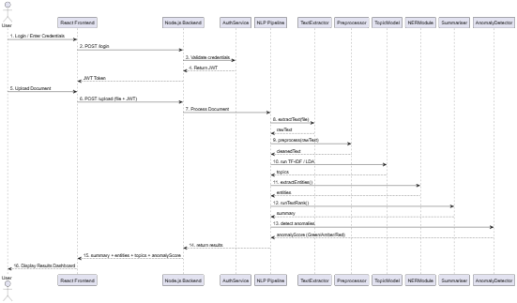
Figure 6 Sequence Diagram

Data Requirements
The primary data requirements for this project define the nature, structure, volume, flow, and constraints associated with the financial documents which will be processed by the system. Due to the sensitive nature of the financial documents, the data requirements must adhere to strict ethical standards, GDPR compliance, and the various constraints outlined in the non-functional requirements. This section will outline the data types used, the structure of data generated within the NLP pipeline, the data storage design, and the data flow.

Data Sources and Characteristics
The primary datasets used for this project will be anonymised financial documents supplied by Helix Innovation Partnerships Ltd. The documents will be a collection of anonymised management accounts, financial summaries, balance sheets, and supporting commentary. The sample documents sent have so far been PDF versions, however the system will have the ability to manage DOCX or XLSX. The documents fall between structured and semi-structured, with multi-column layouts, tables, and footnotes. It is these unique characteristics that represent the challenge identified in the literature reviewed. This challenge is more significant in larger records, which may span multiple pages and contain more tables or columns. (Upadhyay et al., 2025).
Each of the documents utilised in this project were anonymised before being made available to the system. This was to ensure compliance with the ATU ethics requirements and also GDPR restrictions. Research recommended that no personally identifiable information (PII) be present in the documents. Also, the documents should not be shared with or transmitted to any third-party APIs. (Weitzenboeck et al., 2022). By following these guidelines, the project aims to protect and uphold the legal and ethical responsibilities associated with the handling of financial documents.

Data Model and Schema
The documents uploaded to the system will be unstructured which the NLP pipeline will then transform into a structured format. This means that the pipeline module will have three primary schema types:
- Document metadata
- Processed text objects
- Analysis outputs
The documents metadata will include various pieces of information about the financial document. Some of this would be the file name, document ID, file type, upload timestamp, user ID, and storage location. The processed text object will then capture the extracted text, token lists, lemmatised sequence, and the intermediate topic-modelling vectors. Following this the extracted entities will be stored as structured JSON objects containing the entity type, span, token location, and confidence score. This type of structure is similar to that used in pre-established financial NER datasets such as FiNER-ORD for example. (Shah et al., 2024b).
The outputted schema from the anomaly detection model will include information regarding to the anomaly label, rule trigger, confidence score, and a summarised rationale. The aim around this is to present the user with an interpretable output for easy use and understanding. This will also align with guidelines from the research materials regarding the need for transparency in financial anomaly detection. (Almalki and Masud, 2025).
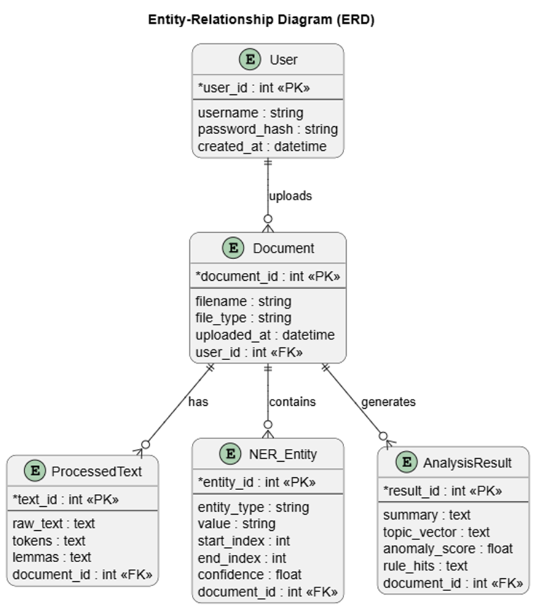
Figure 7 Entity Relationship Diagram

Data Storage Requirements
The system will require storage for three categories of data, user credentials, uploaded files, and analysis outputs. The user credentials will be hashed using bycrypt. This will result in having no plaintext passwords retained within the system, align with the security needs of the system. The uploaded financial documents will only be stored temporarily during the analysis phase of the system life cycle. Following this they will be deleted unless explicitly retained by the system or the user. The aim of this is to reduce the long-term data exposure risks, another key security feature identified in the research materials. The results of the analysis will be stored in a JSON format so as to accommodate re-analysis or user-inspection if needed.
The storage capacity for the system must support the ability for local execution and the ability to perform on a Microsoft Azure cloud environment. This links back to the non-functional requirements stated above and ensures the system will operate under various network conditions. (normesta, no date)

Data Flow
Data flow within the system starts when the user uploads the financial documents at the frontend. The file will be transferred securely, using HTTPS to the system backend where it will be stored temporarily. The file is then transferred to the text extraction module where machine readable text is outputted to the user. Sequentially, the processed text will flow through the NLP pipeline where it will undergo pre-processing, topic modelling, NER, summarisation, and given an anomaly scoring.
At each stage of the system lifecycle intermediate data representation are created, with only the final outputs being returned to the frontend. Modular data flow and minimal coupling between stages is the aim when designing this section. (Garlan and Shaw, 1993). The results will be displayed on the system frontend via React. This will allow the user to review the generated summaries, the entities, and the anomaly indicators.
The aim is to create build the data flow so that it moves in a strictly unidirectional way, for the benefit of user safety. This can be seen demonstrated in Figure 8 below. The aim is to have no data exit the system environment or interact with an external API, aligning with the compliance guidelines set out.
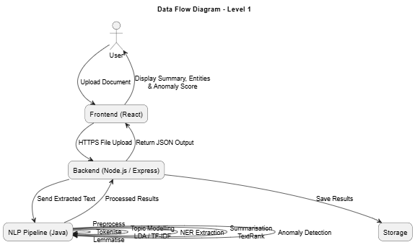
Figure 8 Data Flow Diagram

Data Volume and Performance Constraints
The system will be aimed to small to medium documents, roughly 0.5 – 5 MB. These are the typical sizes for financial documents and management reports. The processing requirements for the system aims to be in under three seconds for the small documents, as stated in the system non-functional requirements. The overall design of the system will ensure that there will be minimal overhead as the system will only perform essential functions related to NLP.
The chosen algorithms will allow the system to remain in a preformatted configuration without the need for GPU acceleration. This aligns with the reviewed literature which shows that lighter-weight NLP pipelines are more suited for analysing the financial documents, especially when reliability and understanding are significant over the need for any deep learning accuracy. (Adedoyin Tolulope Oyewole et al., 2024).

Data Privacy, Ethics, and Security Requirements
Strict data handling rules govern this project as, even though they are anonymised, the system will be handling real financial documents. No document will be transferred to any external services, with the exception of within the Azure environment. To ensure the data does not move beyond the environment, local processing will be the primary mode. This follows the standards and practices defined within the literature reviewed which highlights the risks of transferring financial documents to APIs. (Almalki and Masud, 2025).
The store documents will be encrypted and transmitted via HTTPs. Users will be required to be authenticated before accessing the system so as to comply with GDPR guidelines. Adhering to these guidelines not only ensures the system not only follows industry standards but also follows the ATU ethic guidelines.

Data Quality Requirements
In order to achieve the most accurate results in relation to topic modelling, NER, and summarisation, high quality data is essential. With this, there are a number of points to be considered, such as:
- The extracted text must contain minimal OCR noise.
- The tables and multi-column text, if present, must be preserved.
- Document-relevant terms must be retained at the pre-processing stage.
- A finance-aware list must be implemented with stopword removal.
In the studies reviewed it showed that poor pre-processing will degrade topic coherence score and also reduce the NER precision within the system. (Rahman et al., 2025).

Implementation
The implementation outlines the planned approach for project development. The primary objective is to build a system that is clear, realistic, and a technically justified roadmap that will translate the design into a functioning prototype. The plan for the system design is to have it align with the privacy, reproducibility, and ethical guidelines relevant to the financial document analysis.

Implementation Approach and Development Methodology
The implementation process will follow an iterative Agile model. The feature within an Agile model sees features small increments, which are verified through testing, then refined over a series of sprints. This approach was chosen for its ability to handle the integration of multiple technologies across different runtime environments.
The development activities will be tracked and managed through GitHub, using features such as branches, pull requests, and semantic commit messages. This ensures traceability and maintainability throughout the implementation. Using GitHub also aligns with the best practices in software development and with the guidelines set out for the project itself. (Riordan, 2022).
A weekly sprint cycle will be adopted for the implementation aspect of the project. Each cycle will have distinct deliverables, for example document extraction, NER module integration, and anomaly rule development. At the conclusion of each sprint cycle, the functional progress will be accessed and then logged into the project documentation. This aims to maintain the projects timeline, so as to avoid time constraints in other sprint cycles.

Development Environment and Tools
As stated in the design section, the system will consist of a three-level technology stack. This will feature a React frontend, Node.js/Express for the backend, and a Java NLP pipeline. The separation will ensure the system is modular, testing is feasible, and that it will align with architecture design which was defined earlier.
React.js will be used to create the frontend environment for the system. This will make use of the various functional components within the Reat library, such as Hooks and sematic HTML. The design elements of the system will be aimed to cover the accessibility requirements of the project. They will be supported through the WCAG-aligned design choices which include ARIA labels and implementing proper colour contrast. (Katta, 2025).
Backend functionality will use Node.js and Express in order to create lightweight REST endpoints, implement authentication, and coordinate communication with the NLP pipeline. The security measures put in place will consist of bcryt hashing and JWT authentication. These ensure the system aligns with GDPR and expectations which surround financial data governance. (Jamaludin, 2025).
Java was chosen to develop the NLP model for the project. This was because of its many libraries such as Apache Tika for extraction, Stanford CoreNLP, and its use of unsupervised algorithms such as LDA which can be used for the topic modelling aspect. (Overview of NLP Libraries in Java | Baeldung, 2023). Best practices will be followed, as highlighted within the research literature, so as to ensure the pipeline remains modular and explainable. (Xing and Paul, 2018).
The system should also be configured for Azure, a cloud-based component. Azure will be utilized for its ability to extract information through a Form Recognizer or model hosting in Azure ML. However, this aspect remains optional due to time constraints and resource limitations.

Planned Codebase Structure
As the project will be stored and saved to GitHub, the repository will be broken up into subfolders. There will be folders assigned to each of the major components of the system. Folders will also be created to store the documentation, research notes, and project timelines. Below is an example of the layout for the system aspect:
- Frontend – React user interface.
- Backend – Node.js API, file handling, authentication logic.
- NLP - The Java based NLP pipeline which contains the text extraction, NER, topic modelling, summarisation, and anomaly detection.
As per the project requirements, documentation will be needed for each of the various modules. Unit tests will also be required as well as configuration files. JSON files will be used to document the data exchange between the backend and the NLP layers. This reflects the interoperability across coding languages. (Best practices for repositories, no date).

Step-by-step Implementation Plan
The system implementation will be divided into manageable, sequential staged which align with the technical dependencies.

Sprint 1
The first sprint is centred around establishing the system environment and cementing the overall project workflow. During this sprint, the scaffolds for the frontend and backend, the secure authentication system, and the environment are all configured. Sprint planning is also conducted so as to identify the dependencies, allocate the project resources, and confirm the project plan.

Sprint 2
Sprint two will focus on extending the environmental setup. The workload will be divided into two phases. The first phase will primarily address the initial components of the environment, with the second phase expanding the functionality to support integration with the back and front-end modules. By the end of sprint two, the environment should be fully configured with the appropriate documentation written. These documents will outline the configuration and procedures used in the configuration of the system foundations.

Sprint 3
The third sprint will be the most intensive, spanning roughly thirty days. It will also be divided into two core sections. The first phase will see the implementation of the systems core NLP modules, which includes tokenisation, lemmatisation, and sentence segmentation. The second phase will expand upon these modules with the topic modelling aspect of the system. This will involve techniques such as TF-IDF and LDA, as well as NER which is focused on the financial domain. The extracted entities will be stored in structured JSON so as to support interoperability across the different system layers. This sprint will deliver the essential analytical capabilities for the system and also ensures that the NLP pipeline is functioning as expected.

Sprint 4
The fourth sprint will see the integrating of the systems advanced features. The first phase will introduce the modules relating to summarisation and anomaly detection, while the second phase will refine interoperability and explainability features. This sprint will ensure that the summarisation, which uses TextRank and anomaly detection logic, are aligned with the explainable AI principles. It also ensures that the features provide transparency and reliability so that the system runs as expected within the guidelines set out.

Sprint 5
The final sprint will consolidate the project. The first phase will focus on the remaining testing, that being unit tests or integration testing. The second phase will involve the final project review, ensuring that the system meets the various requirements set out and also making sure all the relevant documentation has been completed.

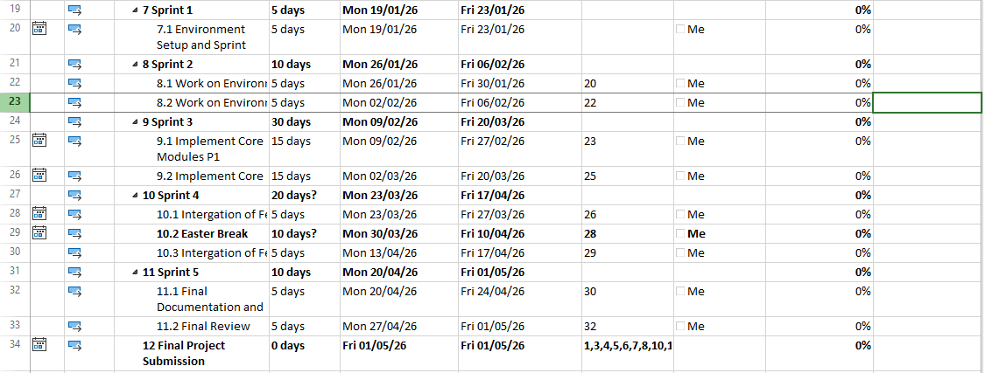
Figure 9 Sprint Timeline

Deployment and Runtime Strategy
Deployment for the system will be supported in two modes:

Local Deployment
In local deployment, the system will be running entirely on the user’s machine. This deployment method is best suited for offline testing, iterative deployment, and ensure privacy during the workflow. The backend section is where the Java-based NLP pipeline will be hosted. This pipeline enables text extraction, pre-processing, topic modelling, and anomaly detection to be implemented and extracted without the need for external services. This deployment method also ensures that the financial data, which is sensitive in nature, does not leave the constraints of the system and remains isolated.

Cloud Deployment (Resource depending)
Where resources and time constraints allow, the system will also support deployment to the cloud via Azure App Services. This mode of deployment would have the NLP pipeline be containerised and executed within an Azure instance. This allows for elasticity in the terms of project scaling and implementation with other Azure services. Cloud deployment also comes with numerous advantages such as:
- High availability
- Automated scaling
- Simplified maintenance
This deployment option aligns with the local deployment mode as it offers a gateway to scale the system beyond its original development, while still staying inline with the system expectations and guidelines.

Privacy, Security, and Data Governance
As stated before, each of the uploaded documents will remain private and confidential. The processing of said documents will adhere to GDPR guidelines of data minimisation, purpose limitation, and storage limitation. (Regulation (EU) 2016/679 of the European Parliament and of the Council of 27 April 2016 on the protection of natural persons with regard to the processing of personal data and on the free movement of such data, and repealing Directive 95/46/EC (General Data Protection Regulation) (Text with EEA relevance), 2016). The uploaded documents will be removed after the analysis has been completed unless explicitly required to be kept on file within the system.
When handling any errors that may arise within the system the logs will exclude the documents content. The aim is to have the logs reference the documents IDs rather than the raw text itself.

Error Handling and System Observability
The system will employ defensive security techniques to defect invalid user input, invalid file types, or extraction failures. The backend system controllers will return structured JSON error messages to the user should any errors be detected. The NLP pipeline aspect of the system will support timeouts and fallback states.
In order to generate consistent diagnostic logs, a structured logging framework will be implemented. An example would be Winston which is used for Node.js. This will support debugging, auditability, and maintainability within the project which aligns with best practices for a complex NLP pipeline. (Isaiah, 2025)

Testing Strategy
A full testing strategy will be cover in Section 6 of this report. Below are a few of the key tests which will included:
- Unit tests
- Validation of the accuracy of extracted information
- Performance testing
- UI validation
These tests will target both the functional and non-functional requirements of the system.

Testing & Evaluation
The quality assurance backbone of the project will consist of testing and evaluation. Testing and evaluation ensure that the system will perform as expected and that the system operates securely. Working with financial data is considered to be high risk due to it sensitive nature, which means that the testing aspect of the system is not just limited to the functionality of the system as a whole but also the workings of the data itself.
Testing will be done iteratively, beginning with unit tests during the development stage and further expanding to integration and then to full end-to-end evaluation of the system performance. The aims of this stage approach is to reduce defect propagation, support traceability, and ensures alignment with the set-out system requirements. (Wild and Lichter, 2023).

Testing Objectives
The testing phase of this project aims to verify the following functions:
- The functional correctness of the uploaded financial documents, NLP extraction, NER, summarisation, and anomaly detection.
- Comply with the performance requirements.
- Adhere to the security and privacy requirements associated with financial document handling.
- Accuracy and reliability of the NLP outputs.
- The overall usability and accessibility of the system for the end user.
- The stability of the system under expected and edge-case financial document inputs.
These objectives link with the functional and non-functional requirements set out earlier in the report. Ensuring traceability through the evaluation lifecycle.

Testing Methodology
Level | Description | When performed
Unit Testing | Testing of individual functions or modules in an isolated environment | During the development
Integration Testing | Interaction between the NLP pipeline, backend, and UI | Mid-project
System Testing | Full document through analysis workflow | After the implementation of core features
User Testing | Feedback from Gatekeeper | Final phase
Table 1 Testing Methodology

Unit Testing Plan
The unit testing element of the project will implement using
- Jest for the backend route testing aspect. (Getting Started · Jest, 2025).
- React Testing Library for the UI components of the frontend. (React Testing Library | Testing Library, 2024).
- JUnit of the NLP components as they will be constructed using Java.
There will be some key areas where unit testing will primarily focus on within the system. Such areas include verifying the robustness of the file validation and uploading, ensuring that tokenisation will produce accurate results and that preprocessing outputs are consistent. The unit tests will do checks to confirm that the rule-based anomaly functionality triggers work as expected, while also assessing whether the summary outputs meet the pre-defined requirements.

Integration Testing Plan
Integration testing will be used to validate the communication between the three primary subsystem within the main system.

Frontend -> Backend
- JWT tokens successfully validate.
- Document both the accepted and rejected uploads.
- Render the correct error feedback to the user.

Backend -> NLP pipeline
- The output from the text extraction is machine-readable output.
- The results from the NER and Topic Modelling are correctly serialised as JSON.

Backend <-> Storage
- Temporary document persistence works reliably.
- Results are stored and are retrievable without corruption.

The integration success will require each module to maintain interoperability without the need for manual intervention.

System / End-to-End Workflow Testing
The system will process a financial document from the upload to the extraction, to the NLP, and finally to the results visualization phase.
The evaluation metrics are as follows:
Metric | Target
Processing the latency | Estimated 3 seconds per small document
Result completeness | The appropriate generation of the summary, topic, entities, and anomaly score
UI responsiveness | < 200ms user input feedback delay
Table 2 Evaluation Metrics

The workflow of the system will be executed using various document types, for example PDF, DOCS, XLSX. This ensures robustness across realistic formats found within the financial sector.

NLP Evaluation Metrics
Due the NLP models handling unstructured financial language, the evaluation will include both quantitative and qualitative measures.

NER Evaluation
- As demonstrated in the FiNER-ORD benchmarking, high precision is critical in the context of financial document analysis.

Topic Modelling Evaluation
- The coherence score will be used to access the topic clarity.
- The topics will be reviewed by the user to evaluate readability and interpretation.

Summarisation Evaluation
- ROUGE-1 and ROUGE-L scores will be used to evaluate the extractive summary overlap.

Anomaly Detection Evaluation
- Rule transparency must be maintained system wide for proper explainability.

Security & Penetration Testing
Testing the security of the system is essential given the sensitivity of the financial documents. Therefore, the following is a list of the planned security validations:
- Attempt access to the system with expired of invalid tokens.
- Malicious file upload attempts.
- Inspection of the log outputs for accidental leakage of textual content.
- Static dependency risk scanning.
The main go of this testing phase is to verify that the defence is strong against any document-based exploits.

Success Criteria
For the system to be considered acceptably evaluated it must meet the following criteria:
- All critical requirements must be met without any exceptions.
- End-to-end workflow completes reliably across different document types.
- The output from the NLP achieves reasonable domain accuracy.
- The results of the summary and anomaly analysis are meaningful to financial experts.
- Processing speed meets NFR target thresholds.
- There is no privacy-breaks or data-leaks in the system.
If any of the set-out conditions fails, another iteration cycle will take place until the condition passes.

Conclusion
The aim of this project is to design an NLP-driven system which processes the capabilities to perform a pre-review on financial documents. The system will extract several key pieces of information, identify entities which may be of importance, generate concise summaries, and also detect and flag potential anomalies. The research completed to date has provided a strong technical foundation which will be used to build the system. The combination of literature review, system requirement analysis, and implementing a project plan has demonstrated both the feasibility and the value of applying NLP-based automation functionality to early-stage financial document review.
The area which the project is aimed has proved to be a problem domain and one of practical industry relevance. Research shows that manual review is labour-intensive, prone to human error, and can be demanding and in terms of time. The system proposed will offer a structured and automated solution, which implements modules for text extraction, pre-processing, topic modelling, NER, summarisation, and rule-based anomaly detection. The system design provides an emphasises on transparency and interpretability. This aligns with the pre-established industry grade standards and guidelines.
This report saw significant attention given to the requirement engineering aspect of the project. This was to ensure that the system will not only be functional, but also scalable, portable, secure, and maintainable. Other aspects of this report focused on the architectural design and data modelling which established the modular and extensible structure the project will adopt. This will be seen in the ability for independent development of the frontend, backend, and NLP pipeline layers of the system. The implementation defines a clear plan for the development of the system using iterative sprints. Each sprint has a dedicated target to be met, representing a project milestone.
While the project still remains in its early stages, the research shows that a fully functional prototype is achievable within the project’s timeline. However, there are challenges that should be acknowledged. That being that text extraction from the financial documents may result in reduced accuracy and may also require a fallback should the process prove to be too difficult to work with. Another area of complexity would be the NLP-based anomaly detection section. Financial anomalies often context-specific and may end up requiring adaptive learning or historical comparison datasets. Even with these being potential challenges, they also represent areas for future improvements rather than limitations of the feasibility.

References
Adedoyin Tolulope Oyewole et al. (2024) “Automating financial reporting with natural language processing: A review and case analysis,” World Journal of Advanced Research and Reviews, 21(3), pp. 575–589. Available at: https://doi.org/10.30574/wjarr.2024.21.3.0688.
Almalki, F. and Masud, M. (2025) “Financial Fraud Detection Using Explainable AI and Stacking Ensemble Methods.” arXiv. Available at: https://doi.org/10.48550/arXiv.2505.10050.
Badmus, O., Toromade, R.O. and Adebayo, A.S. (2025) “(PDF) Embedding AI into ESG-Financial Reporting Frameworks to Advance Trustworthy Non-Financial Disclosures and Data-Driven Investment Decisions,” ResearchGate [Preprint]. Available at: https://doi.org/10.55248/gengpi.6.0725.25165.
Best practices for repositories (no date) GitHub Docs. Available at: https://docs-internal.github.com/en/repositories/creating-and-managing-repositories/best-practices-for-repositories (Accessed: November 26, 2025).
Chae, K. et al. (2024) “Mitigating Hallucination in Abstractive Summarization with Domain-Conditional Mutual Information,” in Findings of the Association for Computational Linguistics: NAACL 2024, pp. 1809–1820. Available at: https://doi.org/10.18653/v1/2024.findings-naacl.117.
Du, K. et al. (2025) “Natural language processing in finance: A survey,” Information Fusion, 115, p. 102755. Available at: https://doi.org/10.1016/j.inffus.2024.102755.
Garlan, D. and Shaw, M. (1993) “AN INTRODUCTION TO SOFTWARE ARCHITECTURE,” in Ambriola, V. and Tortora, G., Series on Software Engineering and Knowledge Engineering. WORLD SCIENTIFIC, pp. 1–39. Available at: https://doi.org/10.1142/9789812798039_0001.
Getting Started · Jest (2025). Available at: https://jestjs.io/docs/getting-started (Accessed: November 28, 2025).
Hegghammer, T. (2022a) “OCR with Tesseract, Amazon Textract, and Google Document AI: a benchmarking experiment,” Journal of Computational Social Science, 5(1), pp. 861–882. Available at: https://doi.org/10.1007/s42001-021-00149-1.
Initiative (WAI), W.W.A. and Henry, S.L. (2005) WCAG 2 Overview, Web Accessibility Initiative (WAI). Available at: https://www.w3.org/WAI/standards-guidelines/wcag/ (Accessed: November 17, 2025).
InstituteAdmin (2025a) “Text Preprocessing Best Practices: Tokenization to Lemmatization,” Business Analytics Institute, 14 May. Available at: https://businessanalyticsinstitute.com/text-preprocessing-best-practices-tokenization-to-lemmatization/ (Accessed: November 14, 2025).
Isaiah, A. (2025) A Complete Guide to Winston Logging in Node.js | Better Stack Community. Available at: https://betterstack.com/community/guides/logging/how-to-install-setup-and-use-winston-and-morgan-to-log-node-js-applications/ (Accessed: November 27, 2025).
Isreal, O. and Alonge, M. (2025) (PDF) Natural Language Processing for Analyzing Financial Texts in Real-Time, ResearchGate. Available at: https://www.researchgate.net/publication/390493872_Natural_Language_Processing_for_Analyzing_Financial_Texts_in_Real-Time (Accessed: September 26, 2025).
Jamaludin, D. (2025) Build a Secure REST API with Node.js, Express, MongoDB, and JWT. Available at: https://www.djamware.com/post/6826fc85f9614f0a093d9cba/build-a-secure-rest-api-with-nodejs-express-mongodb-and-jwt (Accessed: November 26, 2025).
Ji, T., Dong, R. and Driggs-Campbell, K. (2022) “Traversing Supervisor Problem: An Approximately Optimal Approach to Multi-Robot Assistance.” arXiv. Available at: https://doi.org/10.48550/arXiv.2205.01768.
Jin, Y. et al. (2025) “Multi-Stage Field Extraction of Financial Documents with OCR and Compact Vision-Language Models.” arXiv. Available at: https://doi.org/10.48550/arXiv.2510.23066.
JudithPRA (2025) Reglamento general de protección de datos - Microsoft GDPR. Available at: https://learn.microsoft.com/es-es/compliance/regulatory/gdpr (Accessed: November 19, 2025).
Katta, V.K. (2025) “ReactJS and Accessibility: Designing Inclusive Web Applications for Broader Social Impact,” European Journal of Computer Science and Information Technology, 13(31), pp. 99–109. Available at: https://doi.org/10.37745/ejcsit.2013/vol13n3199109.
Larusdottir, M.K., Bjarnadottir, E.R. and Gulliksen, J. (2010) “The Focus on Usability in Testing Practices in Industry,” in P. Forbrig, F. Paternó, and A. Mark Pejtersen (eds.) Human-Computer Interaction. Berlin, Heidelberg: Springer, pp. 98–109. Available at: https://doi.org/10.1007/978-3-642-15231-3_11.
Lin, C.-Y. (2004) “ROUGE: A Package for Automatic Evaluation of Summaries,” in Text Summarization Branches Out. Barcelona, Spain: Association for Computational Linguistics, pp. 74–81. Available at: https://aclanthology.org/W04-1013/ (Accessed: November 12, 2025).
Lu, Y.-T. and Huo, Y. (2025) “Financial Named Entity Recognition: How Far Can LLM Go?” arXiv. Available at: https://doi.org/10.48550/arXiv.2501.02237.
Lundberg, S. and Lee, S.-I. (2017) “A Unified Approach to Interpreting Model Predictions.” arXiv. Available at: https://doi.org/10.48550/arXiv.1705.07874.
mrbullwinkle (2025a) Data, privacy, and security for Azure Direct Models in Azure AI Foundry - Azure AI services. Available at: https://learn.microsoft.com/en-us/azure/ai-foundry/responsible-ai/openai/data-privacy (Accessed: November 13, 2025).
normesta (no date) Azure Storage encryption for data at rest. Available at: https://learn.microsoft.com/en-us/azure/storage/common/storage-service-encryption (Accessed: November 24, 2025).
Overview of NLP Libraries in Java | Baeldung (2023). Available at: https://www.baeldung.com/java-nlp-libraries (Accessed: November 26, 2025).
Papineni, K. et al. (2002a) “BLEU: a method for automatic evaluation of machine translation,” in Proceedings of the 40th Annual Meeting on Association for Computational Linguistics. USA: Association for Computational Linguistics (ACL ’02), pp. 311–318. Available at: https://doi.org/10.3115/1073083.1073135.
Peerdh (2023) Developing A User-friendly Dashboard For Visualizing Anomaly Detection, peerdh.com. Available at: https://peerdh.com/blogs/programming-insights/developing-a-user-friendly-dashboard-for-visualizing-anomaly-detection-results-in-spending-data (Accessed: November 14, 2025).
PricewaterhouseCoopers (2023a) Transforming Conventional Reconciliation and Transaction Monitoring, PwC. Available at: https://www.pwc.com/gx/en/about/analyst-relations/2023/idc-spotlight-pwc-anomaly-detection-platform-2023.html (Accessed: November 14, 2025).
Rahman, M.S. et al. (2025) “AI-Driven Automation of Financial Document Processing: Enhancing Accuracy, Efficiency, and Fraud Detection with OCR, NLP, and Deep Learning,” Library Progress International, pp. 922–928. Available at: https://bpasjournals.com/library-science/index.php/journal/article/view/4183 (Accessed: November 25, 2025).
React Testing Library | Testing Library (2024). Available at: https://testing-library.com/docs/react-testing-library/intro/ (Accessed: November 28, 2025).
Regulation (EU) 2016/679 of the European Parliament and of the Council of 27 April 2016 on the protection of natural persons with regard to the processing of personal data and on the free movement of such data, and repealing Directive 95/46/EC (General Data Protection Regulation) (Text with EEA relevance) (2016) OJ L. Available at: http://data.europa.eu/eli/reg/2016/679/oj (Accessed: November 26, 2025).
Riordan, G. (2022) Git Best Practices – How to Write Meaningful Commits, Effective Pull Requests, and Code Reviews, freeCodeCamp.org. Available at: https://www.freecodecamp.org/news/git-best-practices-commits-and-code-reviews/ (Accessed: November 25, 2025).
Shah, A. et al. (2024a) “FiNER-ORD: Financial Named Entity Recognition Open Research Dataset.”
Upadhyay, S. et al. (2025) On the Comprehensibility of Multi-structured Financial Documents using LLMs and Pre-processing Tools. Available at: https://arxiv.org/html/2506.05182v1 (Accessed: November 23, 2025).
Wang, L. et al. (2024a) “Application of Natural Language Processing in Financial Risk Detection.” arXiv. Available at: https://doi.org/10.48550/arXiv.2406.09765.
Weitzenboeck, E.M. et al. (2022) “The GDPR and unstructured data: is anonymization possible?,” International Data Privacy Law, 12(3), pp. 184–206. Available at: https://doi.org/10.1093/idpl/ipac008.
Wild, N. and Lichter, H. (2023) “Unit Test Based Component Integration Testing,” in 2023 30th Asia-Pacific Software Engineering Conference (APSEC). 2023 30th Asia-Pacific Software Engineering Conference (APSEC), Seoul, Korea, Republic of: IEEE, pp. 1–10. Available at: https://doi.org/10.1109/APSEC60848.2023.00010.
Xing, L. and Paul, M. (2018) “Diagnosing and Improving Topic Models by Analyzing Posterior Variability,” Proceedings of the AAAI Conference on Artificial Intelligence, 32(1). Available at: https://doi.org/10.1609/aaai.v32i1.12033.
Zvornicanin, E. (2022a) “Topic Modeling and Latent Dirichlet Allocation (LDA) | DataScience+,” 30 January. Available at: https://datascienceplus.com/topic-modeling-and-latent-dirichlet-allocation-lda/ (Accessed: October 14, 2025).

Appendix A: Report Structure Example

Project Technical Report
1) Project Overview
- Purpose and objectives of the software
- Scope of the project
- Assumptions, constraints and dependencies
- Definitions and acronyms

2) Requirements
Functional Requirements
- Detailed description of system functions and capabilities
- Input and output specifications
- Data processing operations
- Use cases, user stories (if applicable)
Non-Functional Requirements
- Performance requirements (e.g., response time, throughput)
- Security requirements
- Usability and accessibility standards
- Reliability and availability metrics
- Scalability considerations (if applicable)

3) System Architecture & Design
- Hardware and software requirements (including development and runtime environment)
- High-level system architecture
- Key components/functions/objects and their interactions
- Detailed description of system features, including workflow descriptions.
- Design and implementation constraints
- System qualities (e.g., maintainability, extensibility)
- Security protocols / considerations
- Testing strategy

4) Data Requirements
- Data models and schemas
- Data flow diagrams, class diagram or similar

5) Implementation
- Document the development process
- Code management, version control, etc. (evidence of following best practice)
- Discuss challenges, errors and limitations

6) Testing & Evaluation
- Testing overview / discussing testing requirements
- Functional Testing / Analysis (following testing strategy)
- Results/Evaluation Discussion

7) Conclusion
- Project conclusion/findings
- Limitations
- Future Work

Appendix B: Code Listing / GitHub Project Link
GitHub Project Repo: https://github.com/Oisin003/Final-Year-Project.git
Code Listing 1: PDF Upload Function
Code Listing 2: Text Extraction Function
Code Listing 3: Summarisation Function

